ITI310 - Windows Platform 1

تم هذا العمل بعون الله واشراف الدكتورة
د. دينا الخضري
أعضاء المجموعة من الصف C4_G01
محمد أمير دليواتي mohamed_amir_37174
محمد أديب بيطار mhd_adeeb_39127
مهند دادو mohanad_37307

1:Explain the benefits of using Windows Server 2008
Windows 2008 provides several new benefits that help organizations better administer their networking environment. These new features provide better file and data management, better performance monitoring and reliability tracking tools to identify system problems and proactively address issues, a new image deployment tool, and a whole new set of Group Policy Objects that help administrators better manage users, computers, and other Active Directory objects.
- Improvements in the Group Policy Management:
Windows 2008 introduces over 800 new Group Policy Objects specific to Windows 2008
- Introducing Performance and Reliability Monitoring Tools:
Windows 2008 introduces new and revised performance and reliability monitoring tools intended to help network administrators better understand the health and operations of Windows 2008 systems.
- Introduction of Windows Deployment Services:
Windows 2008 introduces a new tool called Windows Deployment Services (WDS), which is effectively an updated version of the Remote Installation Service (RIS) that has been available for the past several years.
As we have a network consists of 11 workstations we should chose windows server 2008 enterprise edition 64 bit because , it supports 8 processors and up to 2TB of RAM
This edition supports also clusters up to 8 nodes and Active Directory Federated Services (ADFS).
2:Explain what is server core and how it can be used in this company’s situation
The Server Core option is a new minimal installation option that is available when you are deploying the Standard, Enterprise, or Datacenter edition of Windows Server 2008. Server Core provides you with a minimal installation of Windows Server 2008 that supports installing only certain server roles. Contrast this with the Full installation option for Windows Server 2008, which supports installing all available server roles and also other Microsoft or third-party server applications, such as Microsoft Exchange Server or SAP.
Microsoft created an installation option—Server Core—for Windows Server 2008 to eliminate any services and other features that are not essential for the support of certain commonly used server roles. For example, a Domain Name System (DNS) server really doesn't need Windows Internet Explorer installed on it because you wouldn't want to browse the Web from a DNS server for security reasons. And a DNS server doesn't even need a graphical user interface (GUI), because you can manage virtually all aspects of DNS either from the command line using the powerful Dnscmd.exe command, or remotely using the DNS Microsoft Management Console (MMC) snap-in.
To avoid this, Microsoft decided to strip everything from Windows Server 2008 that was not absolutely essential for running core network services like Active Directory Domain Services (AD DS), DNS, Dynamic Host Configuration Protocol (DHCP), File and Print, and a few other server roles. The result is the new Server Core installation option, which can be used to create a server that supports only a limited number of roles and features.
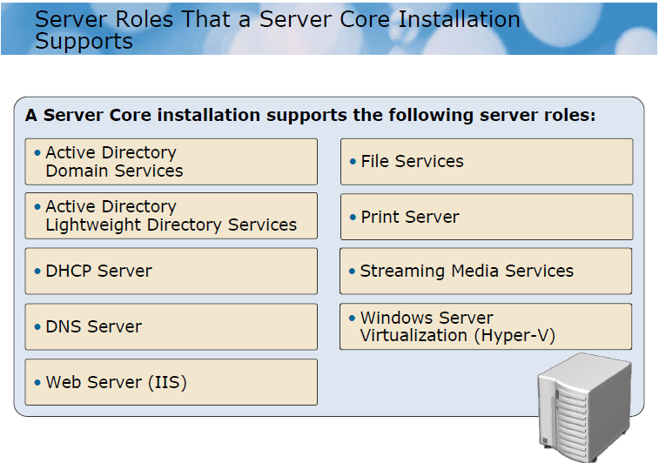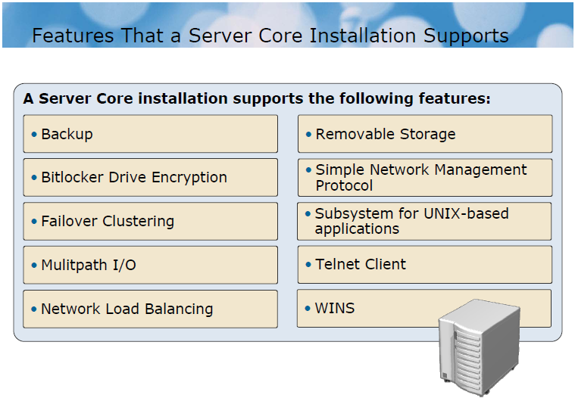
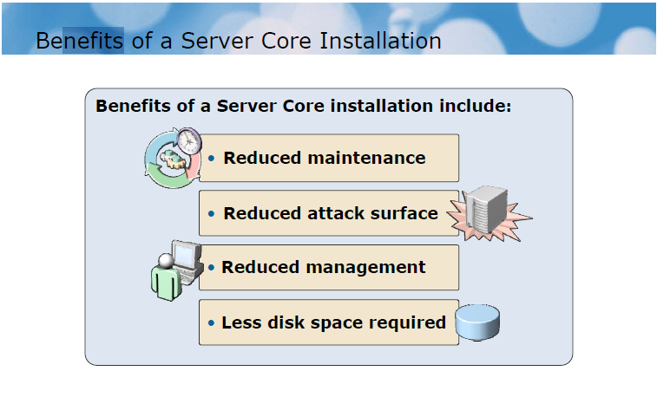
3:Explain the Bitlocker and why it is good to implement it
We can do this by going to the start menu select server manager right click on features add features activate the check of the Bitlocker .
Bitlocker Drive Encryption is a security feature used to encrypt data files and OS files, we used it when we want to encrypt all the data on the volume and when we want to protect our disks from stolen
Bitlocker Drive Encryption uses the Trusted Platform Module (TPM) in the encryption.
TPM is a small part on the mother board.
Bitlocker Drive Encryption is hard to unencrypt because it complete on several level of encryption :
- Encrypt the full volume encryption key who will store in the volume's meta data.
- Meta data is the place who contain the information about this disk.
- the full volume encryption key will be encrypted in another key which called Volume Master Key (VMK) this key who related to TPM.
- There is another key used to more secure called Starter Key related to the user and stored in USB flash to use on the boot operation.
So the Bitlocker Drive Encryption consist of two key .
Encryption level :
- TPM
- TPM and USB flash driver
- USB flash driver
- TPM and Personal information number PIN

Condition of Bitlocker:
- The hard disk contain at least two volume
- BIOS supporting clearing of system RAM on reboot
- The hard disk data type is NTFS
- System volume size at least 1.5GB to store the system
- The second volume store OS file

4:Provide a plan for the network and AD from your perspective of good practice. Add to your written statements, a graphical representation of AD (Active Directory).
Form the list start we chose run icon and write (dcpromo.exe) and press ok then it will show active directory installation wizard
We will chose create a new domain in a new forest
And add the domain name which is :
manucompany.com
The wizard will give us the domain NetBIOS name which is : manucompany
The wizard give us the forest functional level and we will chose the windows 2003 because it provides all active directory for windows 2003 or up
And the domain functional level will be windows 2003 for the same reason
Then we chose from domain additional options : DNS server
Then we will assign a password for the administrator account that will be used when this domain controller is started in directory services restore mode
The wizard will restart the OS when it finished the installation.
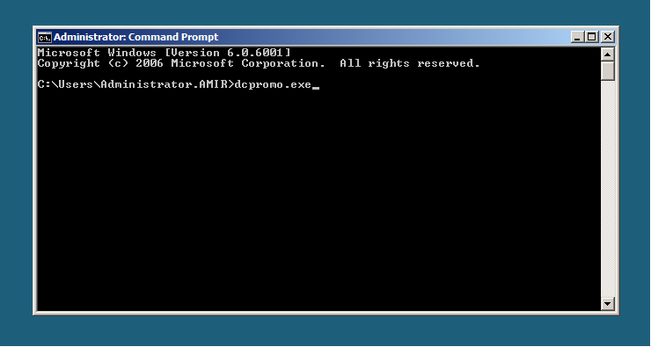
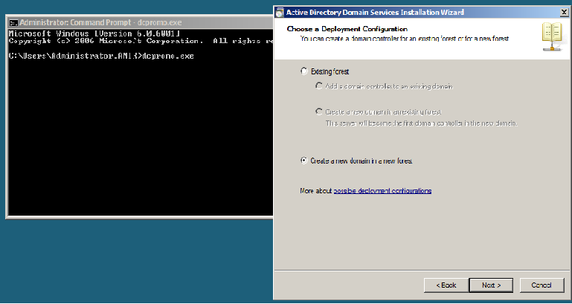
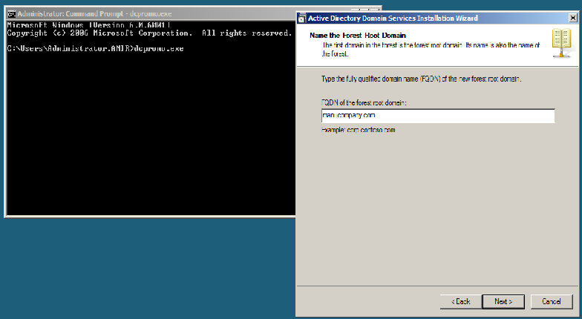
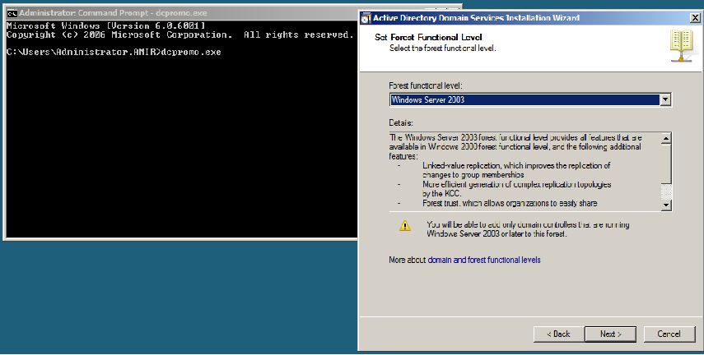
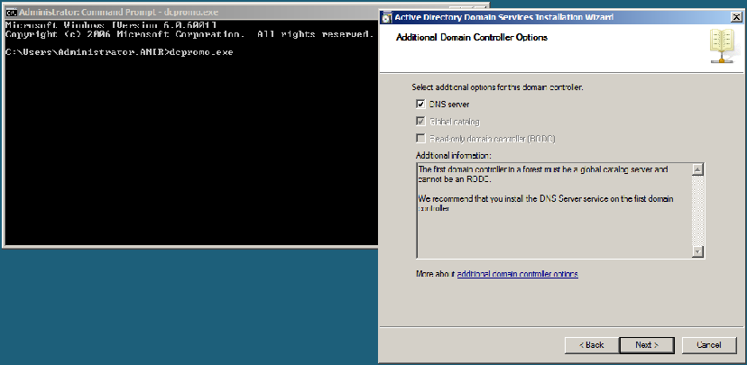
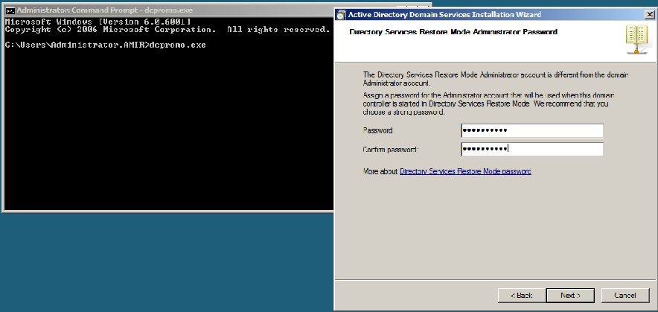
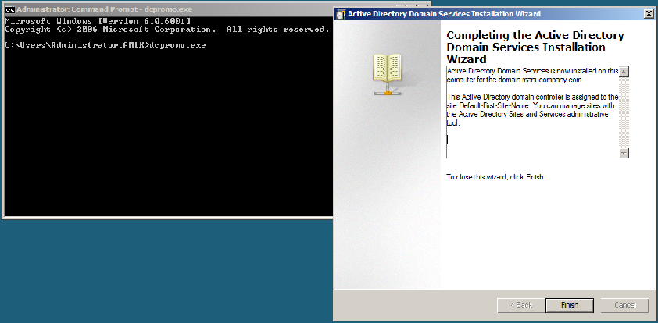

5:Provide a set of privileges for each OU (organizational unit)
From start menu then administrative tools active directory users and computers right click on the manucompany.com
new organizational unit
Right click on organizational unit we will select new user and add the name of user which is President
Then right click on the organizational unit and choose all tasks delegate control to Provide a set of privileges for this OU
Then the same way for the other OUs
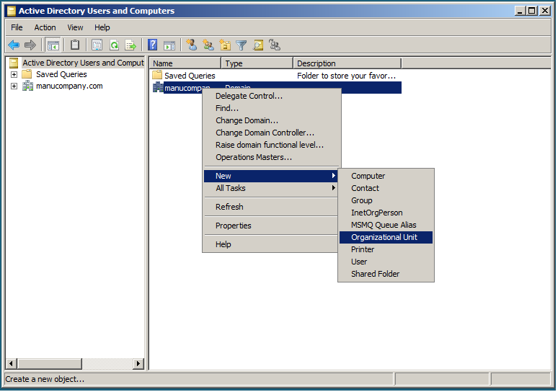
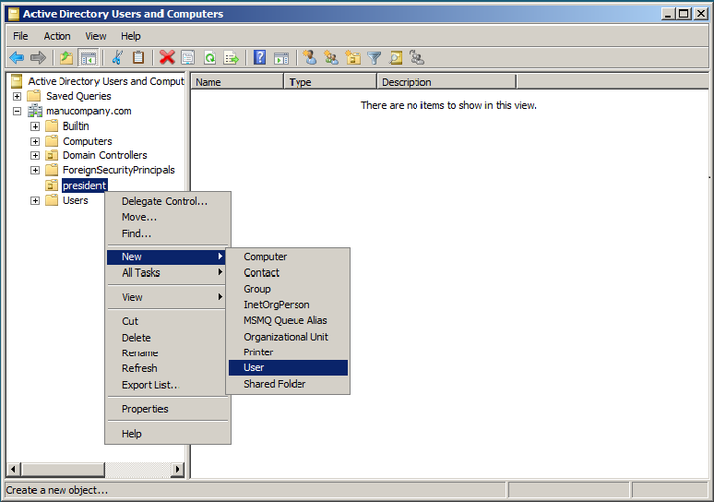
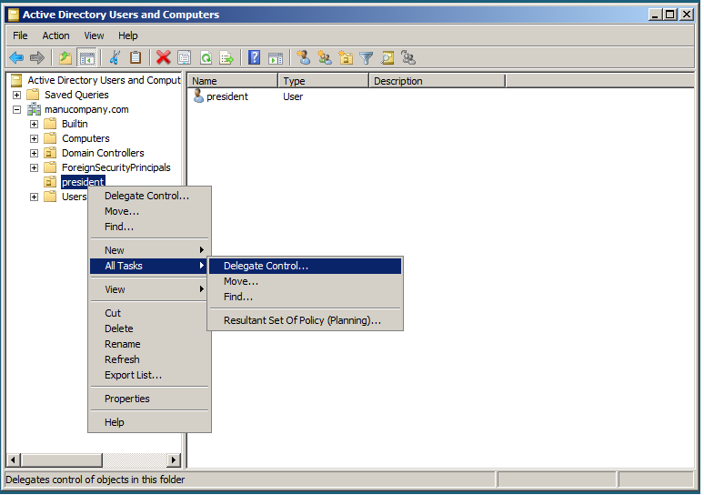

6:Give an example of implementing:
-DNS Server Role
From start menu then administrative tools Server Manager Right click on roles then add roles choose DNS server install

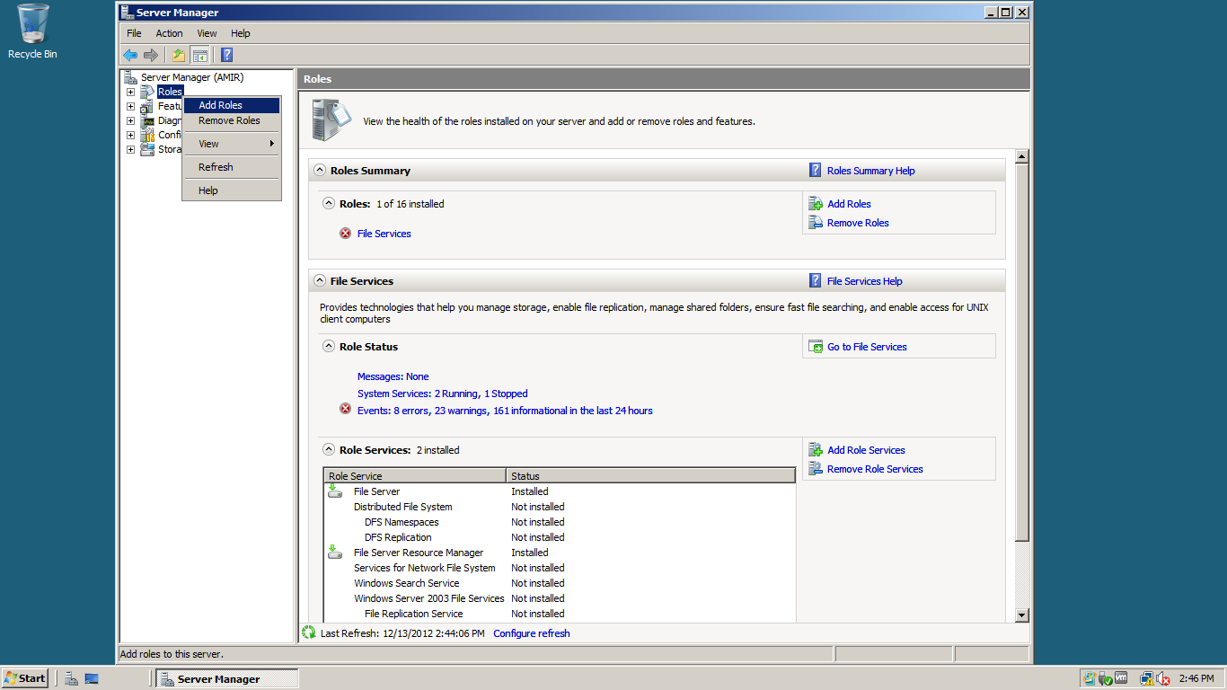
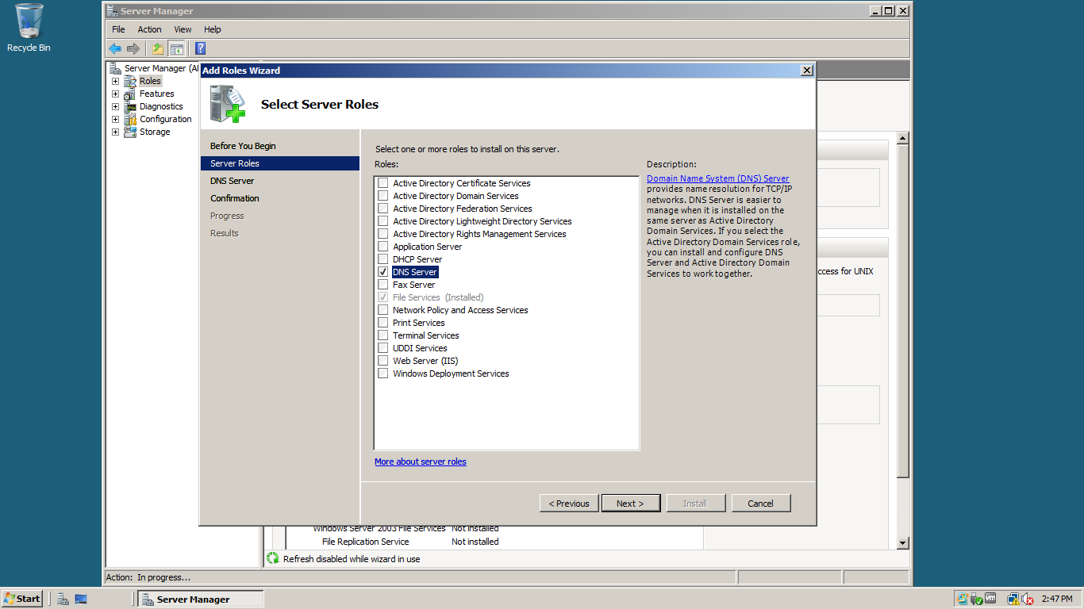
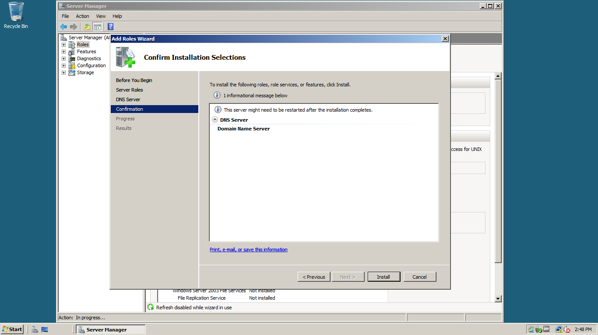
-DHCP Server Role
From start menu then administrative tools Server Manager Right click on roles then add roles choose DHCP server enter the domain name and preferred DNS IP then add a scope to choose the starting and ending IP address install

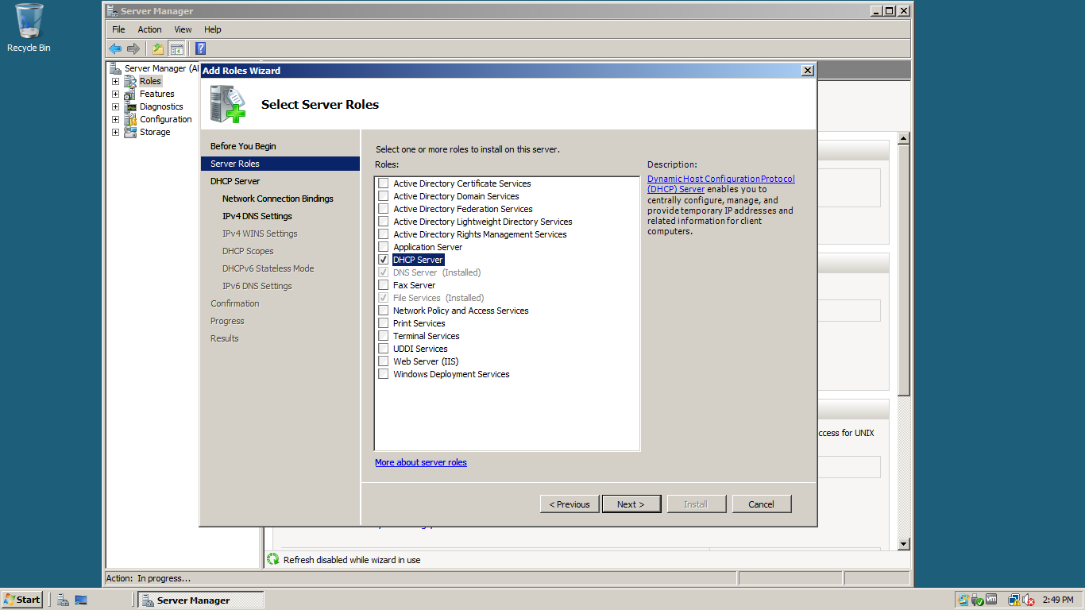
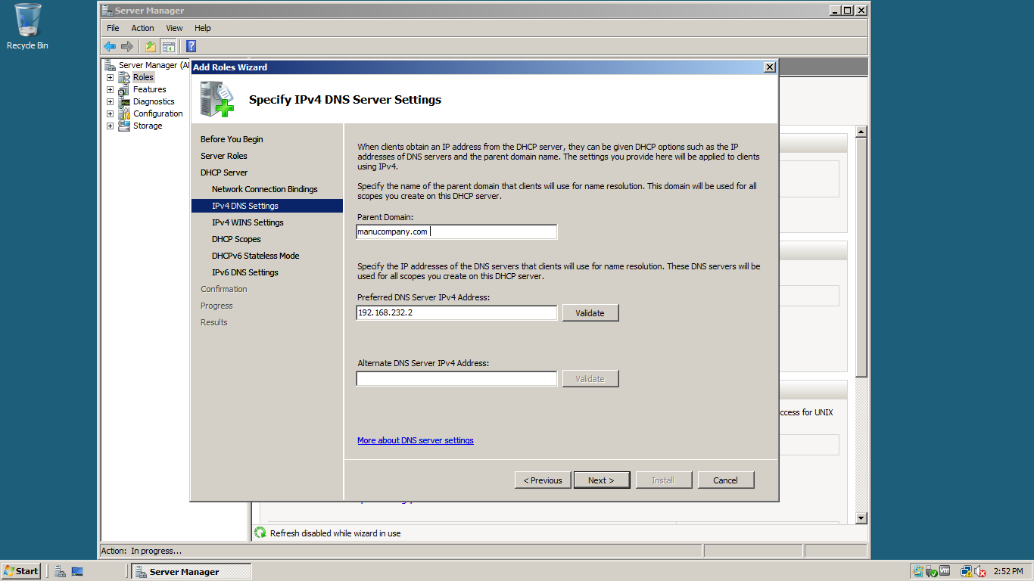
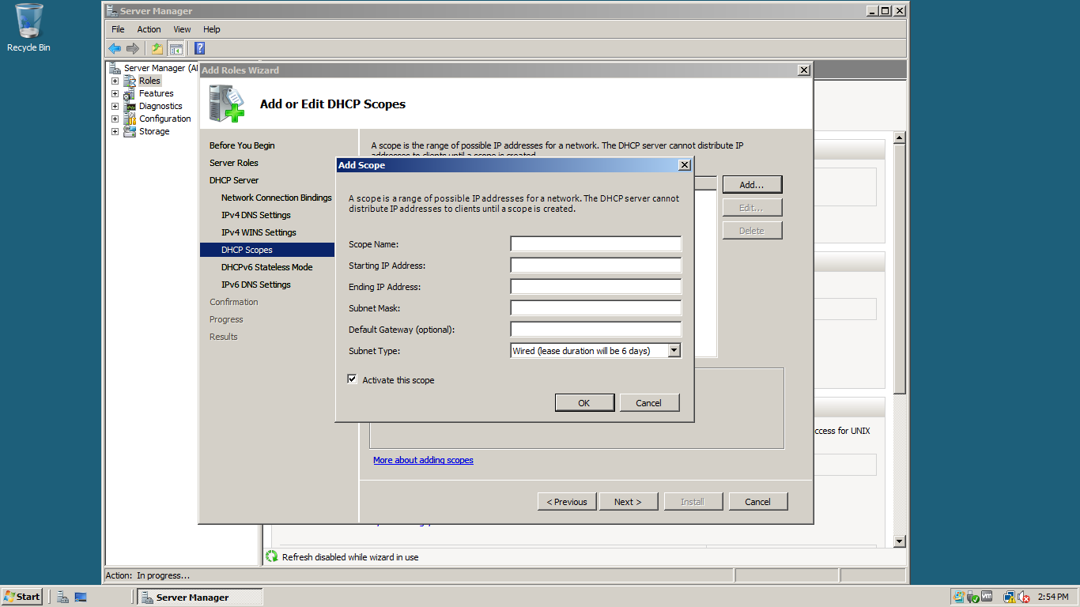
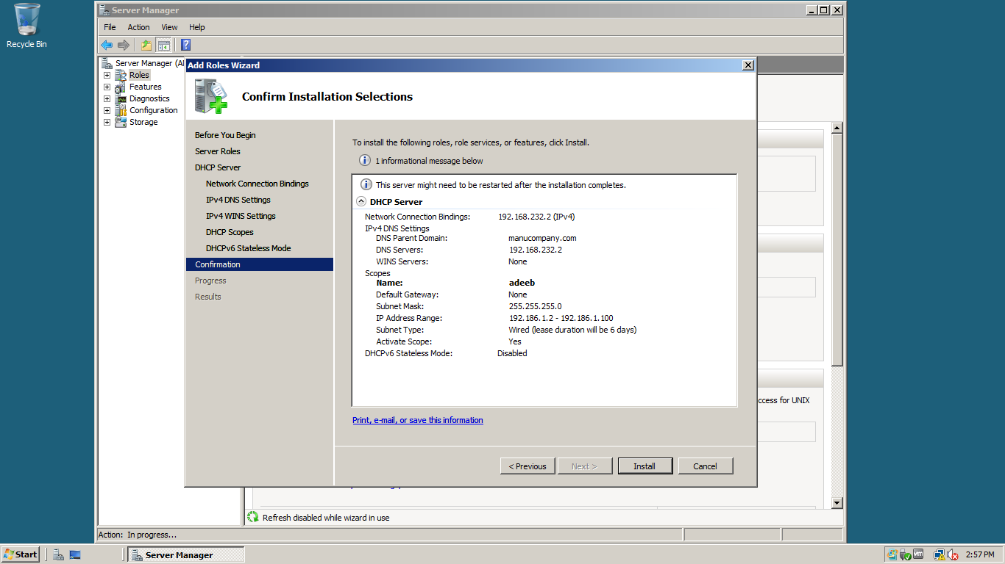

7:If the company would like to host their website on premises, provide a list of required hardware and setting needed

The hardware required is : router to connect your network to the internet and an internet connection like (DSL)
And for the settings we will need to install the IIS core.

8:Provide a plan for disaster recovery. Explain what is needed and an example of the implementation
A disaster recovery plan (DRP) is a documented process or set of procedures to recover and protect a business IT infrastructure in the event of a disaster Such plan, ordinarily documented in written form, specifies procedures an organization is to follow in the event of a disaster. It is "a comprehensive statement of consistent actions to be taken before, during and after a disaster. The disaster could be natural or man-made. Man-made disasters could be intentional (for example, an act of a terrorist) or unintentional (that is, accidental, such as the breakage of a man-made dam).
Organizations cannot always avoid disasters, but with careful planning the effects of a disaster can be minimized The objective of a disaster recovery plan is to minimize downtime and data loss The primary objective is to protect the organization in the event that all or part of its operations and/or computer services are rendered unusable Benefits
There are benefits that can be obtained from the drafting of a disaster recovery plan. Some of these benefits are:
- Providing a sense of security
- Minimizing risk of delays
- Guaranteeing the reliability of standby systems
- Providing a standard for testing the plan
- Minimizing decision-making during a disaster
- Reducing potential legal liabilities
- Lowering unnecessarily stressful work environment
There are three basic strategies that encompass a disaster recovery plan:
- preventive measures.
- detective measures.
- corrective measures.
A disaster recovery plan must answer at least three basic questions:
- what is its objective and purpose.
- who will be the people or teams who will be responsible in case any disruptions happen.
- what will these people do when the disaster strikes.
Disaster Recovery entire process involved in developing a Disaster Recovery Plan consists of 10 steps:
- Obtaining top management commitment
- Establishing a planning committee
- Performing a risk assessment
- Establishing priorities for processing and operations
- Determining recovery strategies
- Collecting data
- Organizing and documenting a written plan
- Developing testing criteria and procedures
- Determining the feasibility and compatibility of backup facilities and procedures.
- Identifying areas in the plan that need modification.
- Providing training to the team managers and team members.
- Demonstrating the ability of the organization to recover.
- Providing motivation for maintaining and updating the disaster recovery plan.
- Testing the plan
- Obtaining plan approval

